**PROS:**

* Seems to allow multiple sessions (no Invalid Session errors) since page refreshes when clicking Edit.
* Shows Earliest Priority on main screen (likely doable with AHK).
* Inventors on Country Page is neat.
* Customizable columns in Search Results could be useful.
* **Able to see/import publicly available information.**
  + Seems this can import sometimes but didn’t work other times. Maybe a glitch?
* Printing to PDF creates a neat little recap for the record.
* Can quickly create multiple TM records for multiple countries.
  + Able to append Country to end? Otherwise, need to manually rename like for Madrid filings.
  + **Going back to Search Results SHOWS updates you’ve made, so that’s really cool.**

**CONS:**

* Lots of loading when switching between tabs.
  + Seems to take about 1000ms on first click of a tab, up from 0ms in old system.
    - Maybe we can have some tabs load immediately instead of loading them on-demand?
* Maxes out at three attorneys. I’ve seen some records with EIGHT or more.
  + Doesn’t include Roles. Only shows Attorney 1, Attorney 2, etc.
* **CAPTCHA for updating Client Code or deleting.**
  + 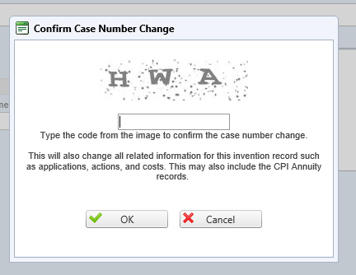
* Earliest priority at BOTTOM of list, feels backwards, but we can adapt.
* When copying Invention screen, prepends “copy” on front by default. Probably configurable.
* **No Resp. field at the Action Due level. Only available for entire action.**
  + We use this when closing Reminders to show who gave permission to close.
* **Remarks don’t seem to generate with actions. Maybe a glitch?**
* Missing some of our fields. Perhaps these are custom?
  + Number of Claims; Art Unit; Examiner; Corres Address; POA; Fee Address; Fee Provider Notes; Instruction Date; TRANIN/TRANOUT Date; Closed Date; etc.
* It would be nice if changes to Country Page Title were reflected on Invention Screen.
  + These are stored separately and must be updated in both places just like our current system. That would be a nice upgrade.
  + Similarly, no Client Ref on Country Page. If only found on Invention, that should be OK.
* Action Due character limit needs to be extended. Tops out at 30 characters. Old system is 50.
* Query interface is confusing and difficult to use. I couldn’t figure out how to run even a test query.